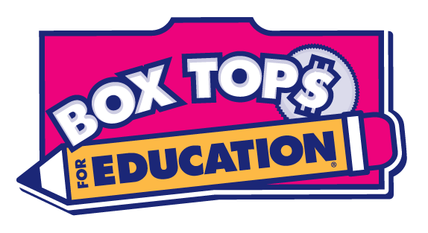 Box Tops Information
2018-2019

L.E. Willson Elementary Media Center will be collecting Box Tops to assist in purchasing books for our library. You can collect Box Tops from over 300 products, like General Mills, Ziploc, Avery, & many more. LEW earns 10¢ for every valid Box Top you turn in! Go to www.BTFE.com or download the Box Top app for additional ways to earn Box Tops.

To help our school, just complete the following steps:
- CUT Box Tops from participating products
- COLLECT in ziploc bags or envelope (or on Box Top page) with your name & teacher
- TURN in to Mrs. Willis
- ASK grandparents, relatives, & friends to help you collect!
- REPEAT!

Box Top Rewards
(Must be valid Box Tops)

25 Box Tops - Visit Mrs. Willis’ Box Top treat bucket
50 Box Tops - Eat lunch with a friend
100 Box Tops - Eat lunch in the library
200 Box Tops - Entered in end-of-year drawing for a Walmart Gift Card

(Rewards will be repeated for additional Box Tops turned in.)

